Understanding PPO Plastic Injection Molding: Benefits, Applications, and Best Practices

# I. Introduction

Plastic injection molding is the most commonly used process in manufacturing. In this process, molten plastic is injected into a heated mold. After cooling and solidification, the plastic material takes the shape of the mold and the finished part is then ejected. Depending on the particular requirements of the product, it may undertake further procedures like trimming assembly, painting, etc. Different plastic products and components for automotive, electrical components, consumer goods, medical equipment, aerospace parts, etc. can be produced with this process. Different types of plastic materials are used in plastic injection molding based on their material properties. One of the commonly used materials for plastic injection molding is Polyphenylene Oxide (PPO).

Polyphenylene Oxide (PPO) is a crystalline thermoplastic. It is widely used for plastic injection molding due to its properties like high-temperature resistance, excellent electrical insulation, resistance to different chemicals, dimensional stability, flame retardancy, versatile application, easy and smooth processing etc.

# II. PPO Plastic

## a. Chemical composition and structure

Structurally, PPO comprises phenylene rings linked together by ether linkages in the 1,4 or para-positions, with methyl groups attached to carbon atoms in the 2 and 6 positions. It is produced by oxidative coupling of phenylene oxide monomer using oxygen and copper-based catalysts. It is resistant to high temperatures with a very high glass transition temperature of 210 0C. However, dueto the difficulty in processing, and poor organic solvent resistance, it is rarely used in its pure form. Therefore, it is commonly used in combination with polystyrene, high-impact styrene-butadiene copolymer, or polyamide to improve melt processability.

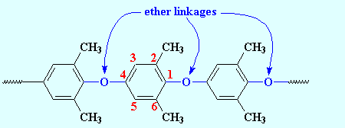

Figure 1 Chemical Structure of PPO

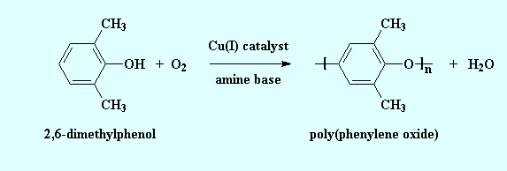

Figure 2 Mechanism of PPO formation(Source: https://pslc.ws/macrog/ppo.htm)

The chemical formula of PPO: (C8H8O) n

## b. Properties of Modified Polyphenylene Oxide (PPO)

|  |  |  |  |  |  |
| --- | --- | --- | --- | --- | --- |
| Chemical Resistance | | Electrical Properties | | Physical properties |  |
| Acids-concentrated | Fair | Dielectric constant @1MHz | 2.7 | Density (g.cm-3) | 1.06 |
| Acids-dilute | Good | Dielectric strength (Kv.mm-1) | 16-20 | Flammability | HB |
| Alcohols | Fair | Dissipation factor @ 1kHz | 0.004 | Limiting oxygen index (%) | 20 |
| Alkalis | Good | Surface resistivity (Ohm/sq) | 2×1016 | Resistance to Ultra-violet | Good |
| Aromatic hydrocarbons | Poor | Volume resistivity (Ohm. cm) | 1017 | Water absorption- over 24 hours (%) | 0.1-0.5 |
| Greases and oils | Fair |  |  |
| Halogens | Poor |  |  |  |  |

Table 1Source: https://www.azom.com/article.aspx?ArticleID=1999

|  |  |  |  |
| --- | --- | --- | --- |
| Mechanical properties | | Thermal properties | |
| Abrasive resistance (mg/1000 cycles) | 20 | Coefficient of thermal expansion (×10-6 K-1) | 60 |
| Coefficient of friction | 0.35 | Heat-deflection temperature -0.45 MPa (0C) | 137 |
| Elongation at break (%) | 50 | Heat deflection temperature -1.8 MPa (0C) | 125 |
| Hardness-Rockwell | M78/R115 | Lower working temperature (0C) | -40 |
| Izod impact strength (J m-1) | 200 | Thermal conductivity (W.m-1. K-1) | 0.22 @ 23 |
| Poisson’s ratio | 0.38 | Upper working temperature(0C) | 80-120 |
| Tensile strength (MPa) | 55-65 |  |  |

## c. Comparison of modified PPO plastic with other plastics

Table 2 Source: https://tinyurl.com/43bzemba

|  |  |  |  |  |  |
| --- | --- | --- | --- | --- | --- |
| Materials | Tensile strength 730F | Flexural Modulus of Elasticity 73 0F | Izod impact  (notched)  730 F | Heat deflection temperature  0F (66psi/264psi) | Water absorption  Immersion 24 hours |
| Units | psi | psi | Ft-lbs/ in of notch | 0F | % |
| ASTM Test | D638 | D790 | D256 | D648 | D570 |
| Nyrol® (modified PPO) | 9,600 | 370,000 | 3.5 | 279/254 | 0.07 |
| High Impact Polystyrene | 3500 | 310,000 | 2.8 | -/ 196 | - |
| Polypropylene (PP) | 5,400 | 225,000 | 1.2 | 210/- | Slight |
| Polycarbonate (PC) | 9,500 | 345,000 | 12.0-16.0 | 280/270 | 0.15 |
| Acrylonitrile Butadiene Styrene (ABS) | 4100 | 304,000 | 7.7 | 200/177 | 0.30 |
| Polyamide (Nylon) | 12,400 | 410,000 | 1.2 | -/194 | 1.20 |
|  |  |  |  |  |  |

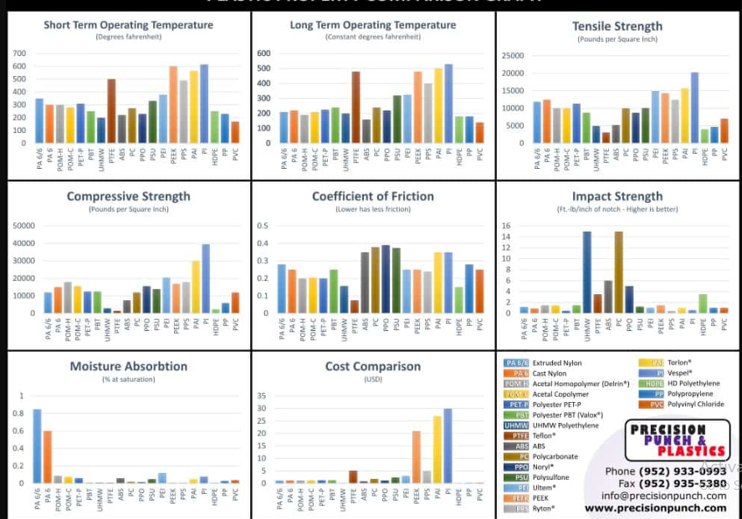

Figure 3 Plastic material comparison chart (source: https://precisionpunch.com/plastic-materials-index/)

## d. Specific features and benefits of PPO and its use in Plastic Injection Molding

1. **High-temperature resistance:** PPO can withstand a wide range of high temperatures making it suitable to be used in heat and thermal stress environments.
2. **Electric insulation:** It has high dielectric strength and low dissipation factor for broad temperature and frequency ranges. Therefore, it is used in the manufacture of different electrical and electronic components.
3. **Chemical resistance:** PPO provides chemical resistance to acids, bases, and solvents. Therefore, it can be utilized in diverse chemical environments. Similarly, it has excellent hydrolytic stability.
4. **Dimensional stability:** PPO offers high dimensional stability because of its low moisture absorption and minimal shrinkage during molding.
5. **Flame retardancy:** It resists the propagation of flames and can also be utilized to achieve the fire-retardancy property in other types of plastic materials.
6. **Cost-effectiveness:** PPO also demonstrates several cost-effectivenesses like reduced manufacturing and labor costs. It can also be combined with other materials like HIPS to meet specific application requirements without increasing in cost.

# III. Common applications of PPO Plastic Injection Molding

* **Automotive industry:** PPO is used in different components like air intake manifolds, engine covers, thermostat housings, etc. It is also used in interior components such as dashboard panels and airbag covers. It is applied in fuel system components, HVAC components, fluid handling components, battery housings, etc.
* **Electrical and electronic industry:** PPO Plastic Injection Molding has several applications in electrical components like connectors and sockets, switch housings, circuit breakers, terminal blocks, fuse holders, electrical enclosures and panels, wire management components, etc.
* **Consumer goods:** It is also used in the manufacturing of diverse consumer goods that include camera bodies and components, TV, audio equipment, drills, saws, kitchenware, cookware handles, luggage and travel accessories, sporting goods, office equipment, etc.
* **Medical industry:** Due to its unique properties, PPO is applied to manufacture housing and enclosures for different medical devices, surgical instruments, respiratory equipment, dental equipment, patient monitoring devices, laboratory equipment, drug delivery devices, bioprocessing equipment, etc.

# IV. The Injection Molding Process with PPO

1. **Material preparation**: PPO must be appropriately dried to eliminate moisture before using PPO resin in injection molding. A baking oven can be utilized for 3 hours dry to PPO plastics, and by heating PPO plastic to 750C- 950C.

**2. Heating and Melting:** All the barrels in the system are carried heat treated to respective corresponding temperature ranges of 2000C to 2600C. The hot flow path adapted to the injection system is heated to 2300C to 2600C. Likewise, the cover half in the injection mold is heated to 650C – 750C, whereas, the dynamic model is heated to 450C – 550C The PPO resin is then loaded into the hopper, where it is subjected to controlled heating with a heated barrel. The resin is converted into molten condition within the temperature range of 2300C to 2700C.

**3. Injection**: When the molten PPO resin reaches the desirable temperature, it is pushed forward to the injection nozzle located at the end of the barrel. The injection pressure is 100kg/cm2- 120kg/cm2, therefore the molten PPO resin is under high pressure. Then the high-pressure molten PPO is injected into the mold cavity through the nozzle. When PPO fills the cavity, it takes the shape of the part to be produced.

**4. Cooling:** The mold is equipped with a cooling apparatus that cools and solidifies the PPO material. The timing of cooling forming is 38s.

**5. Ejection:** After cooling and solidification, the mold is opened and the part is ejected with the

help of the ejection mechanism.

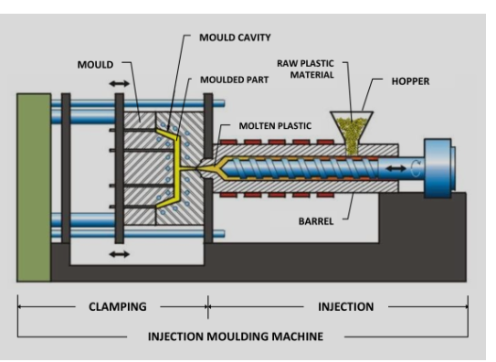

Figure 4 Plastic Injection Molding Mechanism (https://vipol.com.vn/service/plastic- injection-molding/)

# V. Potential challenges and solutions associated with PPO Plastic Injection Molding

a. PPO is hygroscopic and, therefore can lead to the problems like voids, bubbles, and surface defects. For this reason, proper drying of PPO resin should be prioritized.

b. PPO requires high melt temperature that can lead to increased energy consumption and equipment wear. Therefore, regular inspection of the equipment and maintenance of processing parameters like barrel temperature should be emphasized. Selection of the materials or coatings that can withstand wear and tear should be focused.

c. Improper mold temperature can cause warping. Control systems should be regularly monitored to maintain precise temperature control.

d. PPO can be comparatively more expensive than other thermoplastics. That’s why the cost-effectiveness of the performance advantage of PPO should be evaluated.

e. PPO plastic can cause negative impacts on the environment because of its non-biodegradable nature. So, environmentally friendly measures and alternatives should be explored.

# VI. Best Practices for PPO Plastic Injection Molding

**1. Material selection and sourcing:** Based on the specific requirements of the product to be produced, the appropriate grade of PPO should be selected. PPO resins and flame-retardant PPO formulations should be collected from reputable suppliers that meet regulatory and performance requirements.

**2. Mold Design and Considerations:**

* Proper venting and gating
* Effective mold temperature control systems
* Improve the design of parts and mold to reduce the risk of parts failure.
* Experienced mold designers with adequate knowledge of PPO’s characteristics and processing requirements should be engaged in mold design.

**3. Quality control and Testing:** Standard process parameters like injection pressure, temperature, and cooling time based on materials requirements should be developed and optimized. Material testing should be done to verify PPO resin’s quality and consistency. Regular dimensional checks, visual inspection, and testing of performance criteria of finished products should be applied. Proper documentation and recording of process parameters should be emphasized for quality assurance.

# VII. Case Studies

**Case study 1: Permian Plastics Medical device case study**

The Permian Plastics has been serving Noryl GTX PPO/ Nylon resin ( a high-performance blend of polyamide and polyphenylene oxide) It possesses unique properties like high heat resistance, flame resistance, clarity, long wear, and ability to withstand harsh environments. The resin is injection moldable and the final product was a component of emergency warning lights. Likewise, it can also be utilized in automotive lighting and automotive painted body panels.

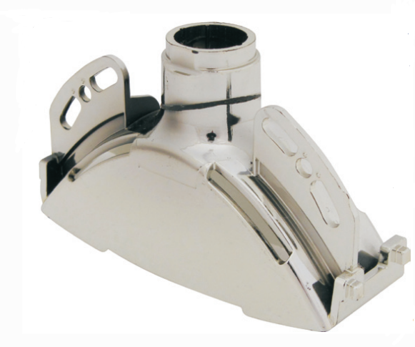

Figure 5 NORYL GTX PPO/Nylon

Source: <https://shorturl.at/dgwHN>

**Lesson learned:** Careful selection of the material properties based on the product requirements and with diverse applications is crucial. Quality control measures should be established to ensure product reliability. It is always beneficial to collaborate with quality material suppliers for product development.

**Case study 2: Modified PPO development and injection molding process for Lightweight Stack Enclosure of hydrogen fuel-cell electric vehicles (FCEV)**

The study emphasizes two factors i) development of modified PPO (mPPO) as an alternative material to aluminum, and ii) optimization of the injection molding process for stack enclosure production. The key findings of the study demonstrated that mPPO was successful at replacing aluminum by reducing the weight of the stack enclosure while maintaining the required properties. Similarly, the study suggested replacing aluminum with mPPO and optimizing the injection molding process. It did not only reduce the weight but also the material costs. Moreover, optimization of the injection molding process on the other hand improves productivity by reducing cycle times.

**Lesson learned:** Material development is crucial to achieving light-weighting goals in the automotive industry. Proper material testing and evaluation should be emphasized to assess the performance requirements of newly developed materials.

# VIII. Future trends in PPO Plastic Injection Molding

Future innovations in PPO materials and molding techniques are more likely to concentrate on environmental sustainability and eco-friendliness. The development of bio-based PPO blends with both improved properties and good recyclability can be considered. Similarly, the reduction of PPO waste production and energy consumption can be obtained with the implementation of a closed-loop recycling system. On the other hand, the application of advanced molding techniques like micro-molding, multi-material molding, and 3D printing to produce different complex PPO components. Also, the forecast done by Research and Markets (the world’s largest market store) states that the polyphenylene oxide (PPO) market was valued at US$1,298.26 million in 2017 and is expected to reach US$1,879.84 million by 2026 with a growth rate of 4.3% during the forecast period. This indicates a significant increase in the value of the market.

# IX. Conclusion

To conclude, PPO offers several exceptional qualities like high-temperature resistance, high dielectric strength, chemical resistance, flame retardancy, and dimensional stability. These properties enhance the versatility of PPO diversifying its application in different industries. Likewise, several problems associated with pure PPO use have been addressed with the development of modified PPO. Moreover, further innovations have been emphasized in PPO materials and molding techniques to improve performance and sustainability. Therefore, PPO injection molding can be a viable choice for the next plastic design and manufacture-related project.